**Report of Ex3_SimElectronics_DC_Motor**

**by: Punit Purohit**

**Submitted to: Dr. Jerry Ku**

**Required Changes:**

The structure of the tree is changed in library and therefore the location of various block has changed. These changes are updated in the PDF.

In Simulink-PS converter rad/s is present instead of rpm (Step 13) and hence select rad/s and if you wish to see plot in rpm add a gain block of ‘60/(2*pi)’

**Results and Discussion:**

The simulation was ran at various steps (21, 26,30, 35, 40, 44) all these results are similar to those in tutorial and are shown below in sequential order.

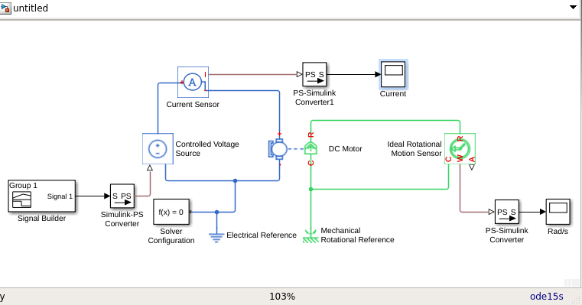

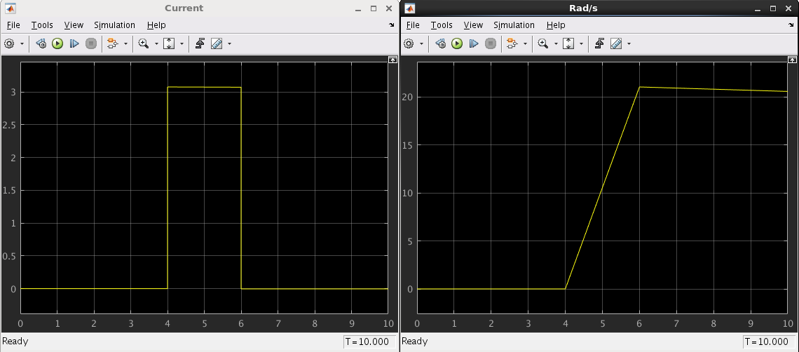

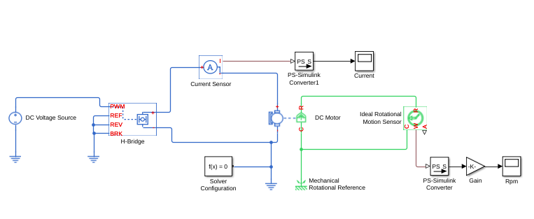

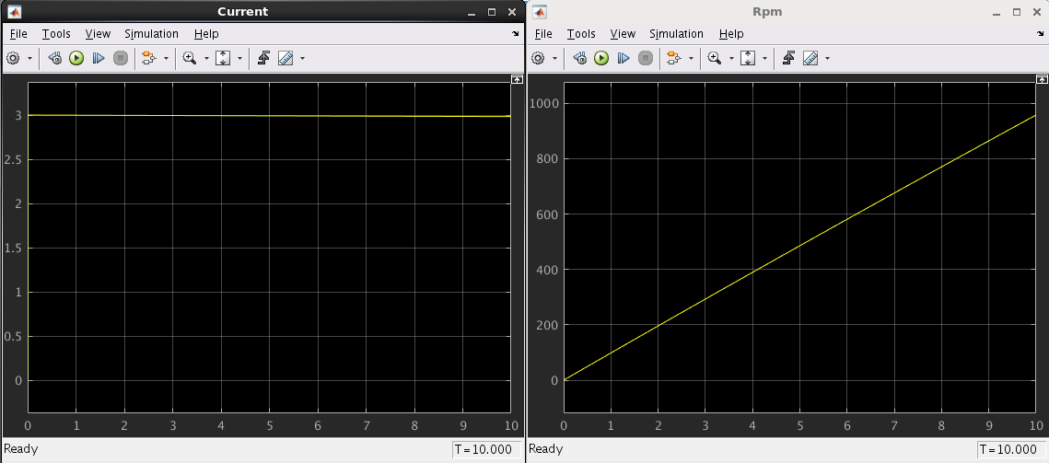

**Reverse Motor Using H-Bridge Control**

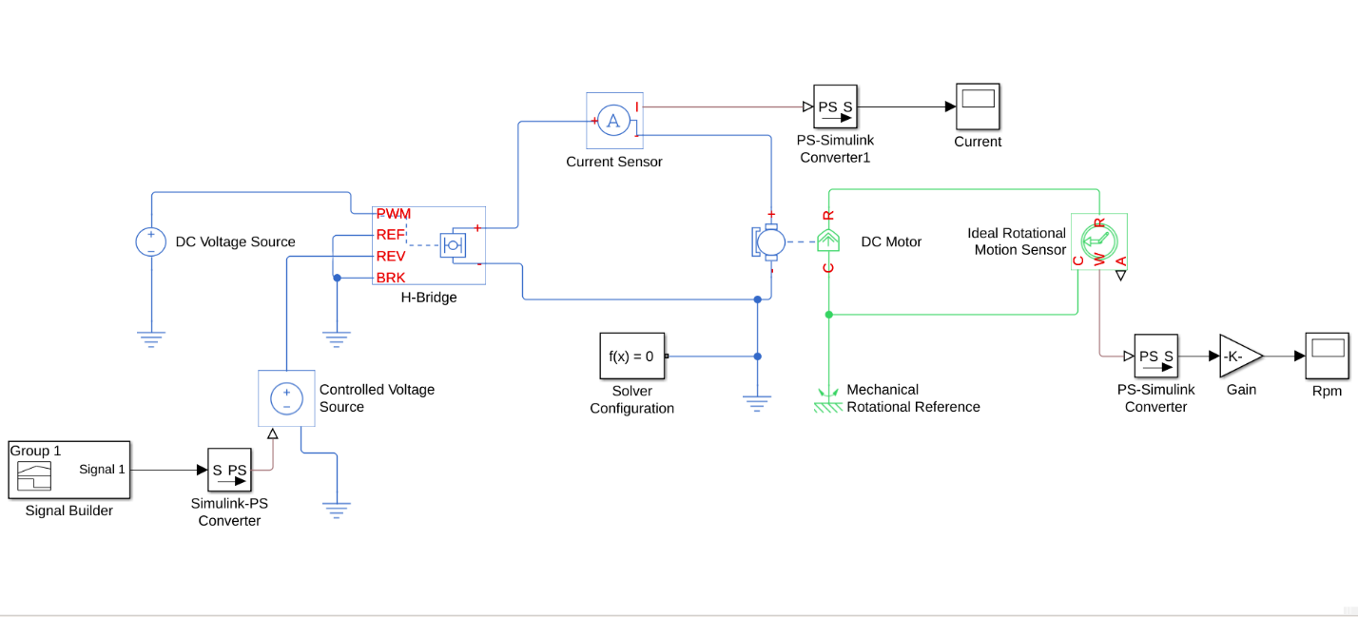

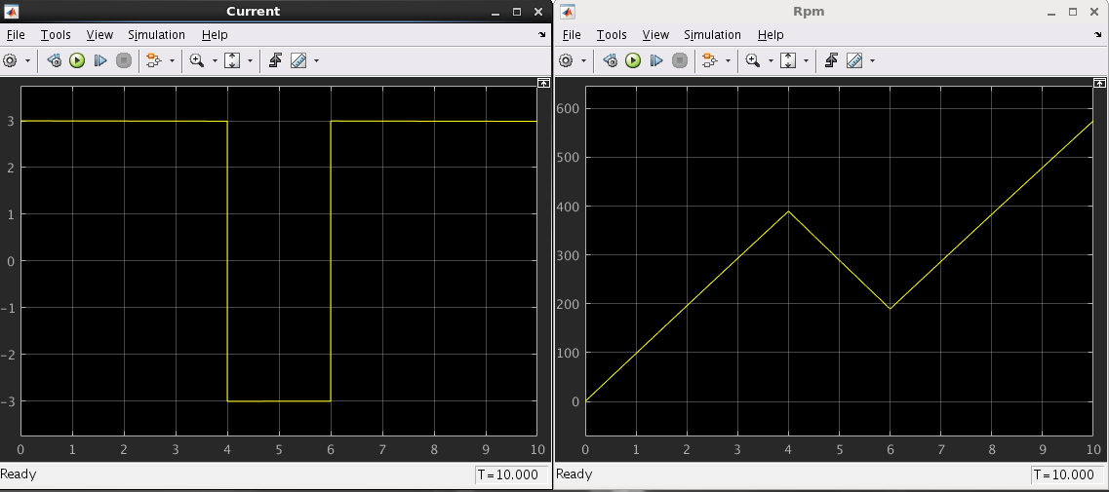

**Braking Using H-Bridge Control**

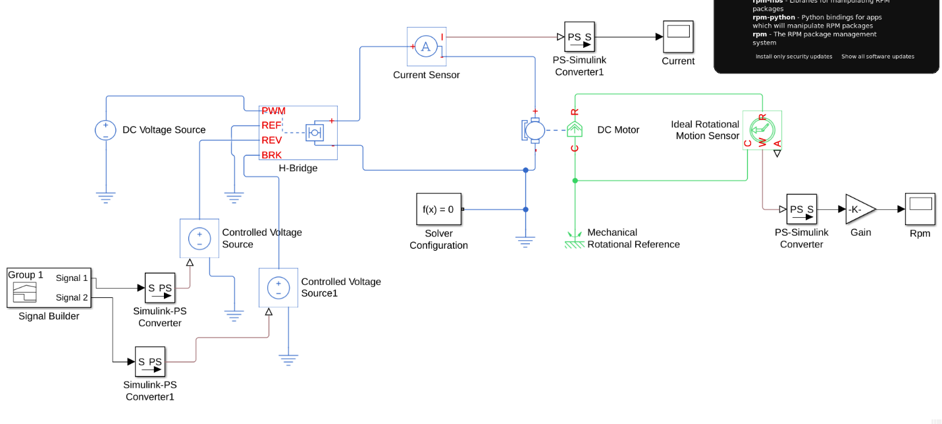

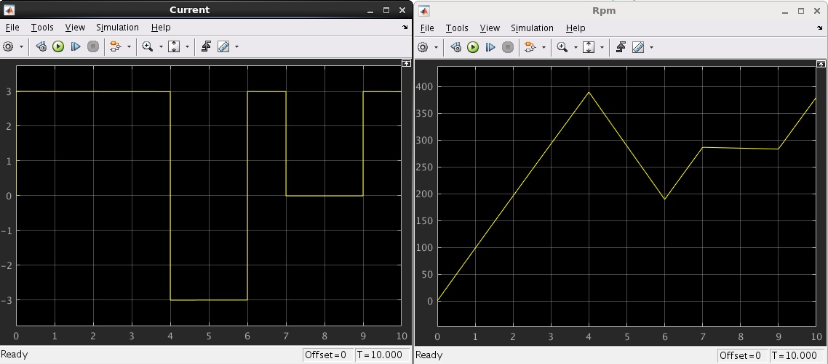

**PWM Driver Control**

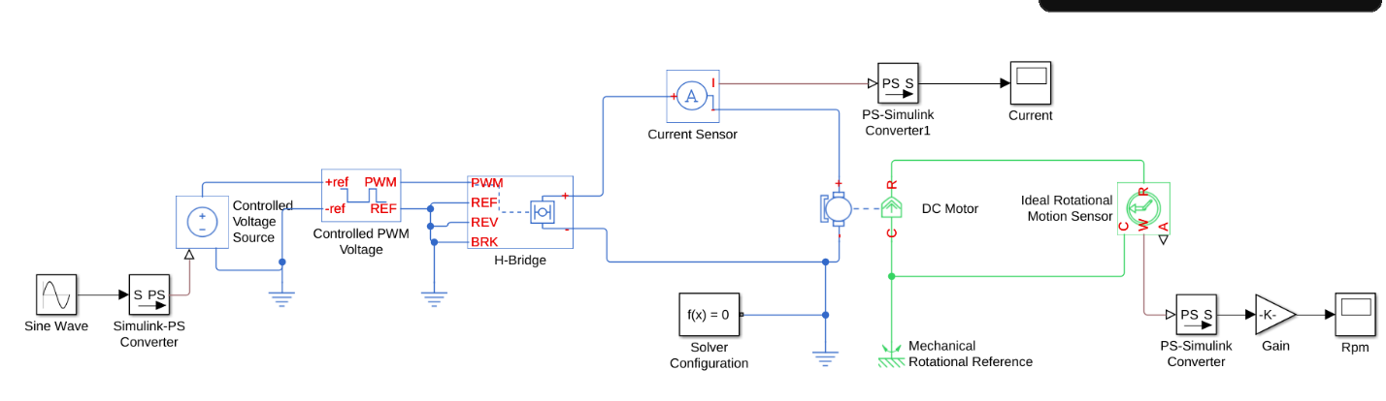

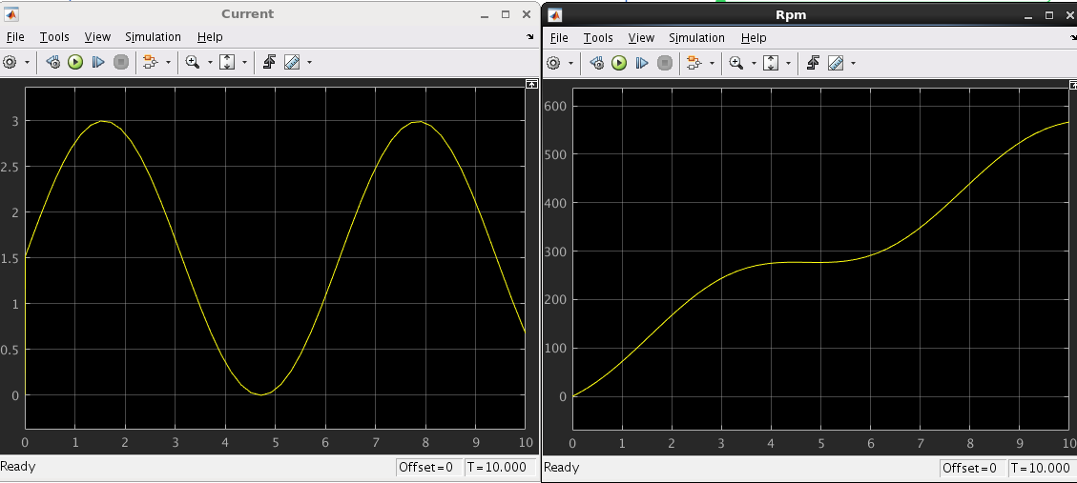

**Verification with PWM Model**

